Homework: Basic Tree Data Structures
This document defines the homework assignments for the "Data Structures" course @ Software University.

Introduction
You are given a tree of N nodes represented as a set of N-1 pairs of nodes (parent node, child node). Below are the operations that you are going implement.
Input | Comments | Tree | Definitions
9  7 19  7 21  7 14  19 1  19 12  19 31  14 23  14 6  27  43 | N = 9  Nodes: 719, 721, 714, 191, 1912, 1931, 1423, 146  P = 27  S = 43 | 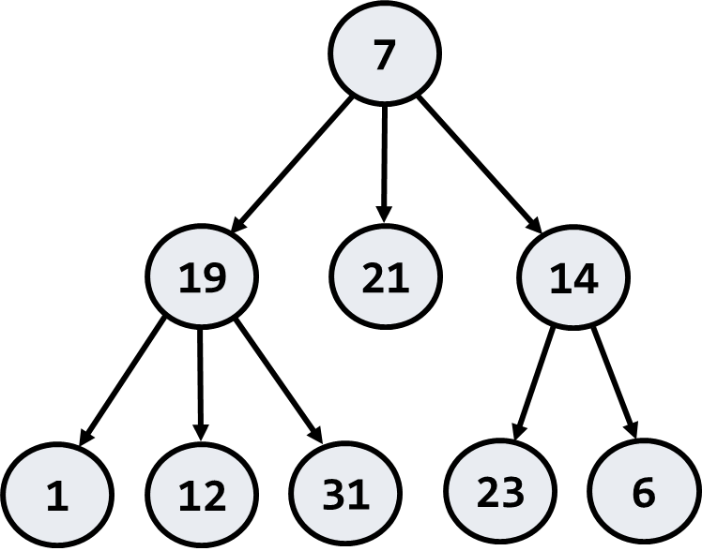 | Root node: 7  Leaf nodes: 1, 6, 12, 21, 23, 31  Middle nodes: 14, 19  Leftmost deepest node: 1  Longest path:  7 -> 19 -> 1 (length = 3)  Paths of sum 27:  7 -> 19 -> 1  7 -> 14 -> 6  Subtrees of sum 43:  14 + 23 + 6

Root Node
Write a program to read the tree and find its root node:
Input | Output | Tree
9  7 19  7 21  7 14  19 1  19 12  19 31  14 23  14 6 | Root node: 7 | 
Hints
Use the recursive Tree<T> definition. Keep the value, parent and children for each tree node:
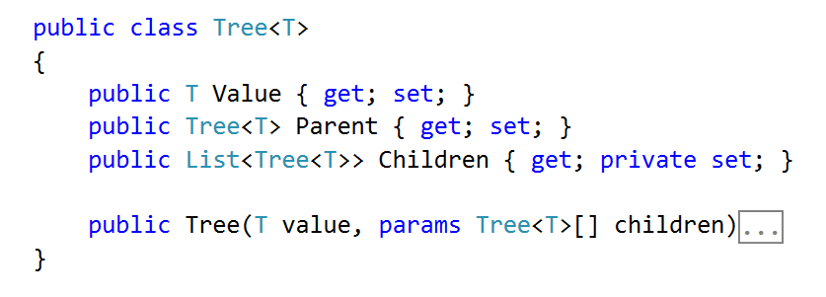
Modify the Tree<T> constructor to assign a parent for each child node:
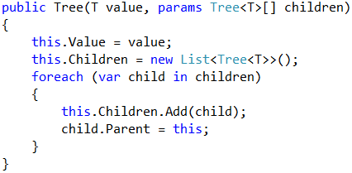
Use a dictionary to map nodes by their value. This will allow you to find the tree nodes during the tree construction (when you read the input data, you get the node values):
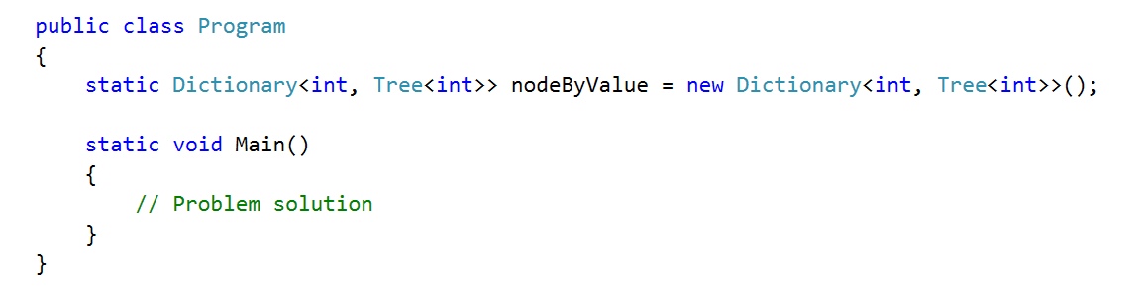
Write a method to find the tree node by its value or create a new node if it does not exist:
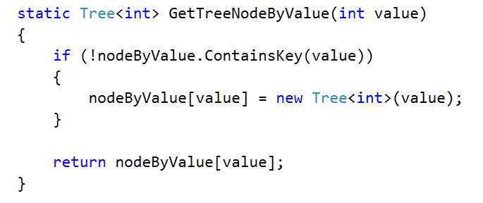
Create a method for adding an edge to the tree
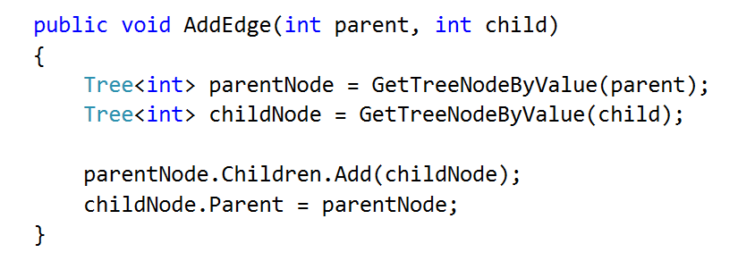
Now you are ready to create the tree. You are given the tree edges (parent + child). Use the dictionary to lookup the parent and child nodes by their values:
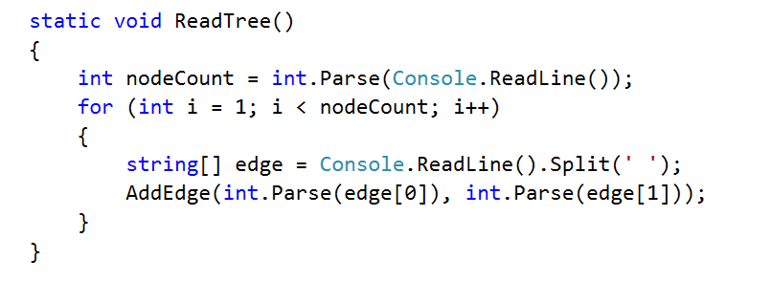
Finally, you can find the root (the node that has no parent)
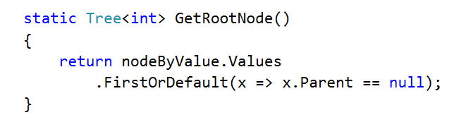

Print Tree
Write a program to read the tree from the console and print it in the following format (each level indented +2 spaces):
Input | Output | Tree
9  7 19  7 21  7 14  19 1  19 12  19 31  14 23  14 6 | 7  19  1  12  31  21  14  23  6 | 
Hints
Find the root and recursively print the tree

Leaf Nodes
Write a program to read the tree and find all leaf nodes (in increasing order):
Input | Output | Tree
9  7 19  7 21  7 14  19 1  19 12  19 31  14 23  14 6 | Leaf nodes: 1 6 12 21 23 31 | 
Hints
Find the all nodes that have no children

Middle Nodes
Write a program to read the tree and find all middle nodes (in increasing order):
Input | Output | Tree
9  7 19  7 21  7 14  19 1  19 12  19 31  14 23  14 6 | Middle nodes: 14 19 | 
Hints
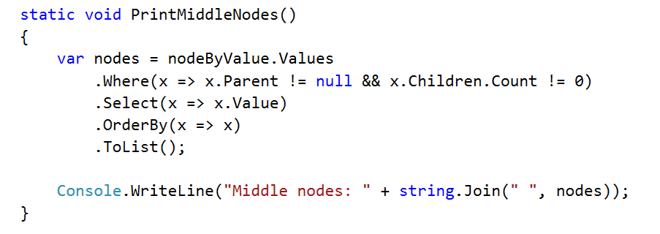

* Deepest Node
Write a program to read the tree and find its deepest node (leftmost):
Input | Output | Tree
9  7 19  7 21  7 14  19 1  19 12  19 31  14 23  14 6 | Deepest node: 1 | 

Longest Path
Find the longest path in the tree (the leftmost if several paths have the same longest length)
Input | Output | Tree
9  7 19  7 21  7 14  19 1  19 12  19 31  14 23  14 6 | Longest path: 7 19 1 | 

All Paths With a Given Sum
Find all paths in the tree with given sum of their nodes (from the leftmost to the rightmost)
Input | Output | Tree
9  7 19  7 21  7 14  19 1  19 12  19 31  14 23  14 6  27 | Paths of sum 27:  7 19 1  7 14 6 | 

* All Subtrees With a Given Sum
Find all subtrees with given sum of their nodes (from the leftmost to the rightmost). Print subtrees in pre-order sequence
Input | Output | Tree
9  7 19  7 21  7 14  19 1  19 12  19 31  14 23  14 6  43 | Subtrees of sum 43:  14 23 6 | 

